OPEN CALL 2022 _ S h o w and t e l l

Name
Email
Website
SNS

S H O W | what do you want to show?
 | -
T E L L | what do you want to tell?
 | -

Please send this document to show_and_tell@naver.com with one of your representative practices

For more information, please visit our website: www.showandtell.kr
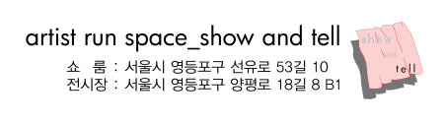
Contact: Yuna Nam <director1> yunayunarang@naver.com / Jihoon Son<director2> cold0111@naver.com

